
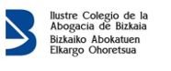
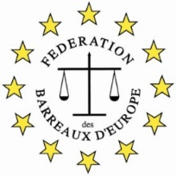
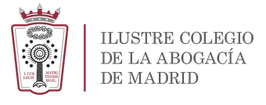

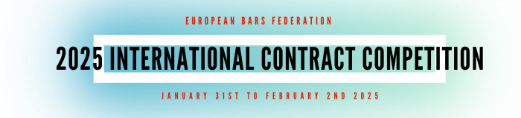

Application Form

The Bar
Participating Bar
Contact Person in the Bar
Phone (international format)
E-mail
The Participant
Participant
Phone
E-mail
Professional Card Number
Additional Notes
Please tell us about your motivation to participate in the competition.

The participant will send the application to the FBE Legal Education Commission (internacional@icam.madrid) and the FBE Arbitration Commission (mcalantropo@gmail.com) and put in copy the Bilbao Bar Association (cri@icasv-bilbao.com) and to the bar association of membership, before 14:00 PM (CET) Monday 20 January 2025.

